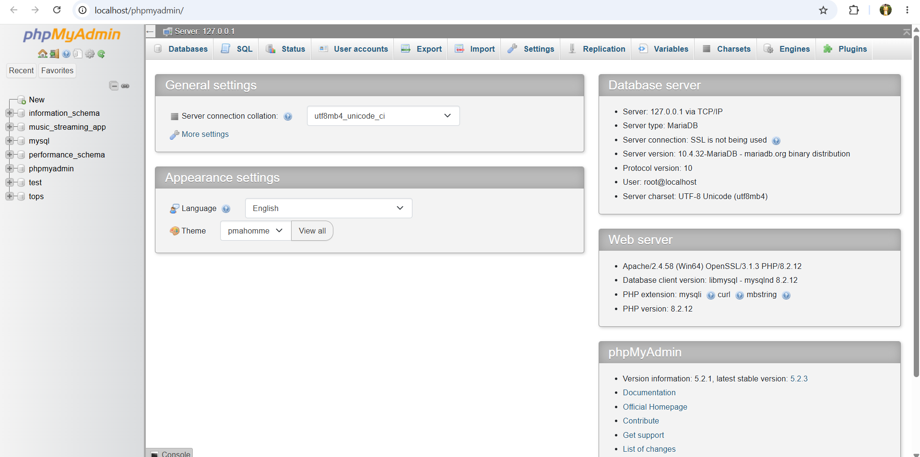

Q1 | Install MySQL or PostgreSQL on your system and create a new database named 'music_streaming_app' using the command line or GUI tool of your choice.
Code | CREATE DATABASE music_streaming_app;
Output | 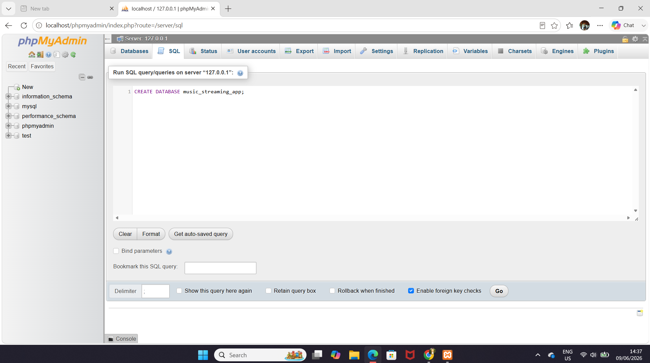  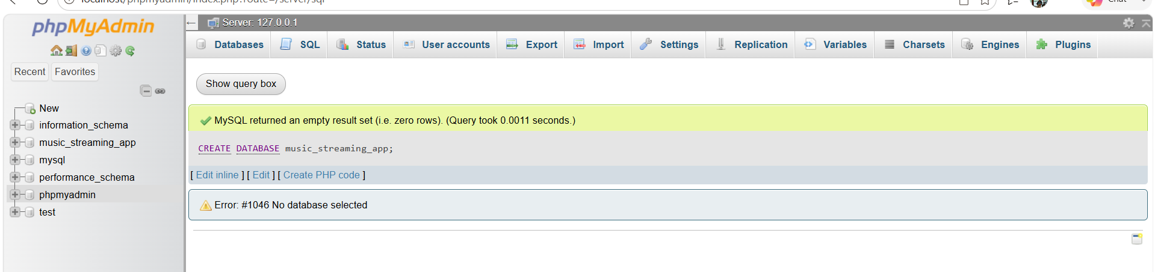

Q2 | Inside the 'music_streaming_app' database, create a table called 'playlists' with columns: playlist_id (integer, primary key), name (varchar), and created_by (varchar).
Code | CREATE TABLE playlists (  playlist_id INT PRIMARY KEY,  name varchar(100),  created_by varchar(100)  );
Output | 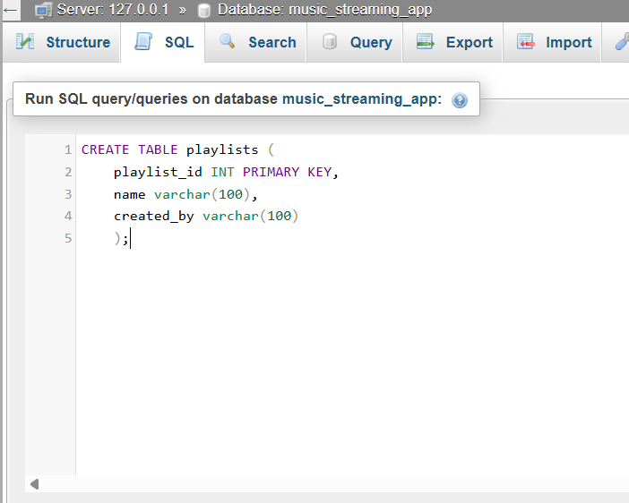  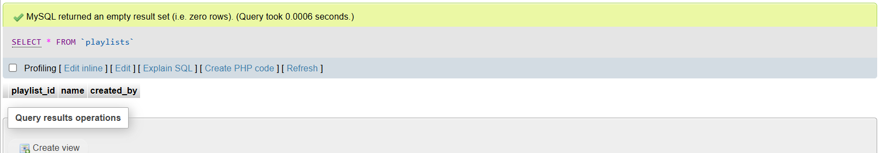  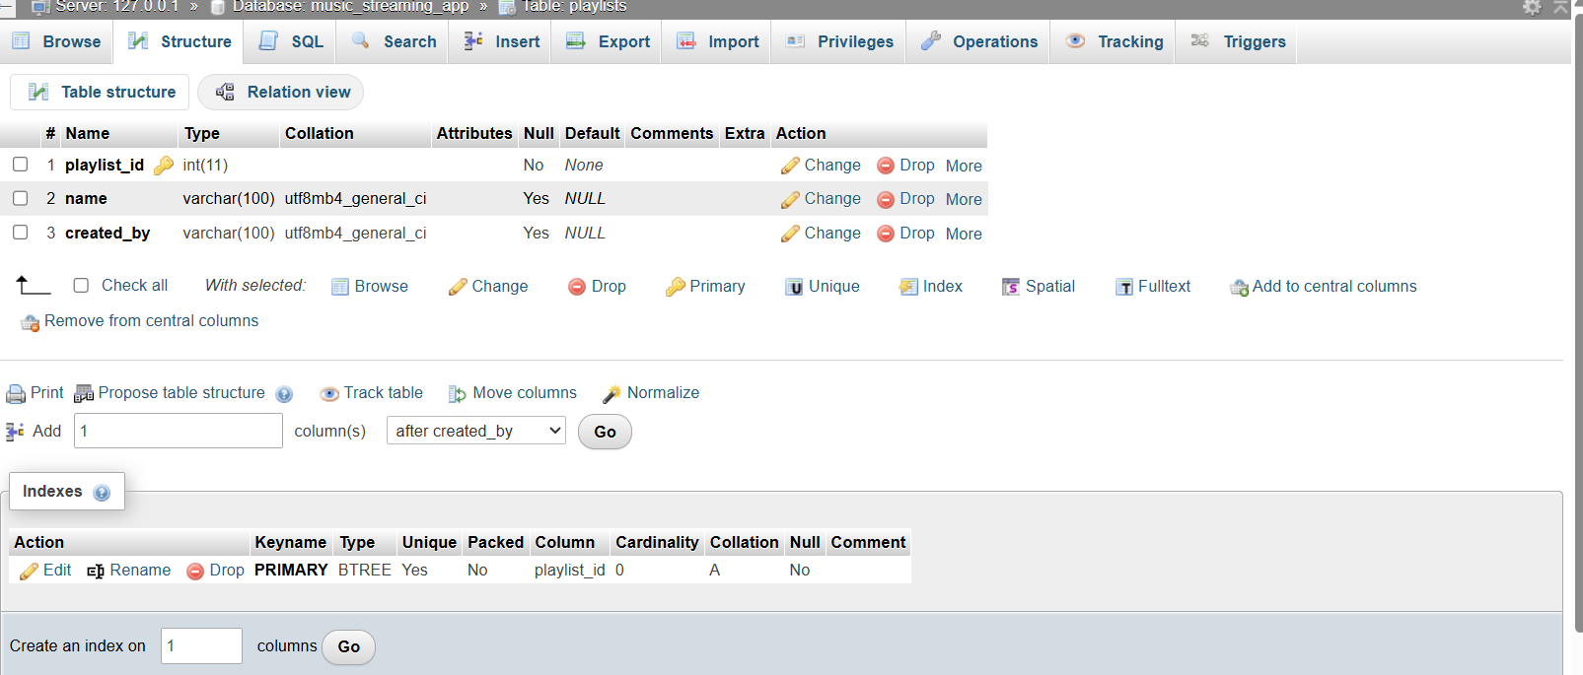

Q3 | Insert three sample rows into the 'playlists' table representing playlists like 'Bollywood Hits', 'Chill Vibes', and 'Workout Mix', each created by a different user.
Code | INSERT INTO playlists (playlist_id, name, created_by)  VALUES  (1, "Bollywood Hits", "Yash"),  (2, "Chill Vibes", "Amit"),  (3, "Workout Mix", "keval");
Output | 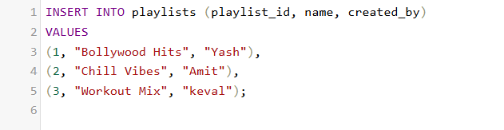  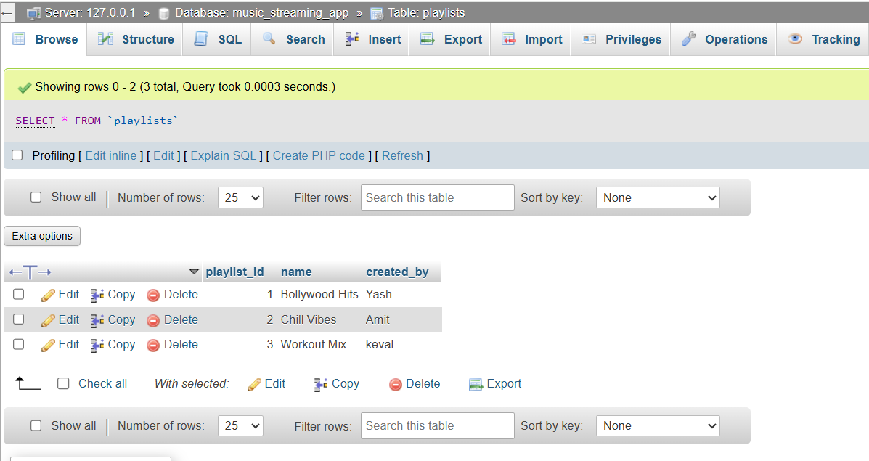

Q4 | Write an SQL SELECT query to display all playlists created by the user 'Amit' from the 'playlists' table.<br><br><em><strong>Hint:</strong> Use the WHERE clause to filter by the 'created_by' column.</em>
Code | SELECT * FROM playlists WHERE created_by = "Amit";
Output | 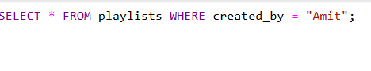  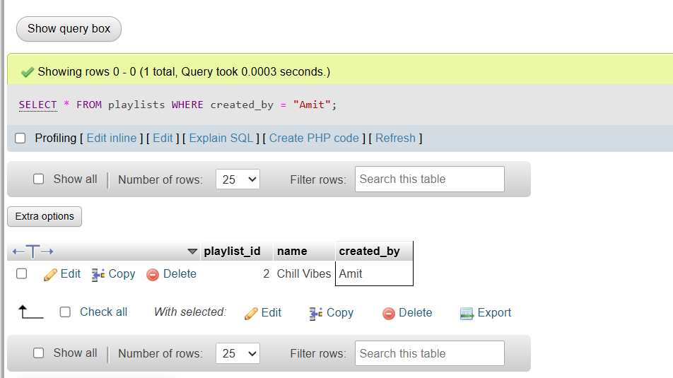

Q5 | Open ChatGPT or Copilot and ask it to explain the difference between a table, a row, and a column in SQL using an example from a food delivery app like Zomato. Paste the explanation you receive into your assignment.
explanation | Difference Between a Table, Row, and Column in SQL (Using a Zomato Example)  - Table:  A table is a collection of related data organized into rows and columns. In a food delivery app like Zomato, a table named "Restaurants" might store information about all registered restaurants.  - Column:  A column represents a specific type of information stored in a table. For example, the Restaurants table may contain columns such as Restaurant_ID, Restaurant_Name, Location, and Rating.  - Row:  A row represents a single record in a table. Each row contains data for one restaurant. For example:  Restaurant_ID: 101  Restaurant_Name: Spice Garden  Location: Ahmedabad  Rating: 4.5  In this example:  - Table: Restaurants  - Columns: Restaurant_ID, Restaurant_Name, Location, Rating  - Row: The complete record for "Spice Garden"  Therefore, a table stores data, columns define the categories of data, and rows contain the individual records.

